Extending Dynamic Range of Electronics in a Time Projection Chamber

J. Esteea,b , W.G. Lyncha,b

*a Michigan State University, Dept. Physics and Astronomy*

*b National Superconducting Cyclotron Laboratory*

**Abstract**

When applying Time Projection Chambers (TPCs) to low and intermediate nuclear collisions one can face challenges in addressing large dynamics ranges in the energy losses of the detected particles. For recent experiments with the SAMURAI Pion-Reconstruction and Ion-Tracker (S*π*RIT) TPC, it was important to detect and analyze the small energy losses of relativistic pions as well as the large energy losses of, slow moving, heavy ions. We illustrate how such large dynamic ranges can be handled in TPC with a wire plane readout by effective use of knowledge the tails of the pad response function distribution. By employing this technique, we are able to increase the signal to noise of dynamics ratio from 1000/1 to xxxx/1. (Get the number. how high can we go?) (do we want to give a number the combination of the pad response function plus the different voltage planes?)

*Keywords:* elsarticle.cls, LATEX, Elsevier, template

*2010 MSC:* 00-01, 99-00

**1. Introduction**

**The challenge of large dynamic ranges in the energy losses of detected particles is widespread and many techniques have been employed to address it. If particle with high energies losses are emitted to different angles or have different ranges or magnetic rigidities, this problem may be solved by separating the particles and peforming the energy loss masurement in different detection volumes.**

**This solution can be problematic, if the**

**solution can be tre**

25

The SAMURAI Pion-Reconstruction and Ion-

Tracker (S*π*RIT) Time Projection Chamber (TPC)

was designed to measure pions and other light

5 charged particles in heavy ion collisions (HICs). A radioactive beam of 132 Sn and 108 Sn was impinged on stable Sn targets. By measuring such neutron rich systems, we intend to extract more information on the nuclear Equation of State (EoS). The focus

30

10 of this paper will be the discussion of extending the dynamic range of the TPC electronics. For other construction details the reader is referenced to [1]. Before I go on to highlight the details of the S*π*RIT TPC and its electronics, it is worth men-

35

15 tioning that the method of extending the dynamic range is not limited to this particular TPC and elec- tronics. Its application could be applied to a host of other TPCs and electronics in general. Extending 40 the dynamic range of the electronics and recover-

20 ing the saturated signals of these particles allows us to perform more meaningful EoS physics over a greater range of momentum and Z.

45

*1.1 TPC Overview.*

*Wire planes.* As seen in figure 1 the S*π*RIT TPC consists of three wire grids above the two dimen- sional array of charge sensitive readout pads, the pad plane. The first two wire grids operate as a gate and a shielding, or ground grid, and they are not important for the discussion of this paper. The wire grid closest to the pad plane is the high voltage anode wire grid. In the near vicinity of these wires the avalanche of the preliminary electrons occurs. The electrons deposited from tracks in the detector gas are multiplied on the order of 1000 times and the slow moving ions moving away induce a signal on the read out pads below. The resulting distri- bution on the pad plane is fixed by the geometry of the anode wire grid and its distance from the pad plane.

*Pad plane.* The S*π*RIT TPC read out plane is a

2-dimensional plane of charge sensitive pads. Each pad being rectangular in shape and is laid out on a grid measuring 112 by 108 pads. The avalanche wires run perpendicular to the beam axis. As seen in the figure 1, the direction the wires go in is re- ferred to as the row direction and the direction per-

*Preprint submitted to Journal of LATEX Templates August 24, 2017*

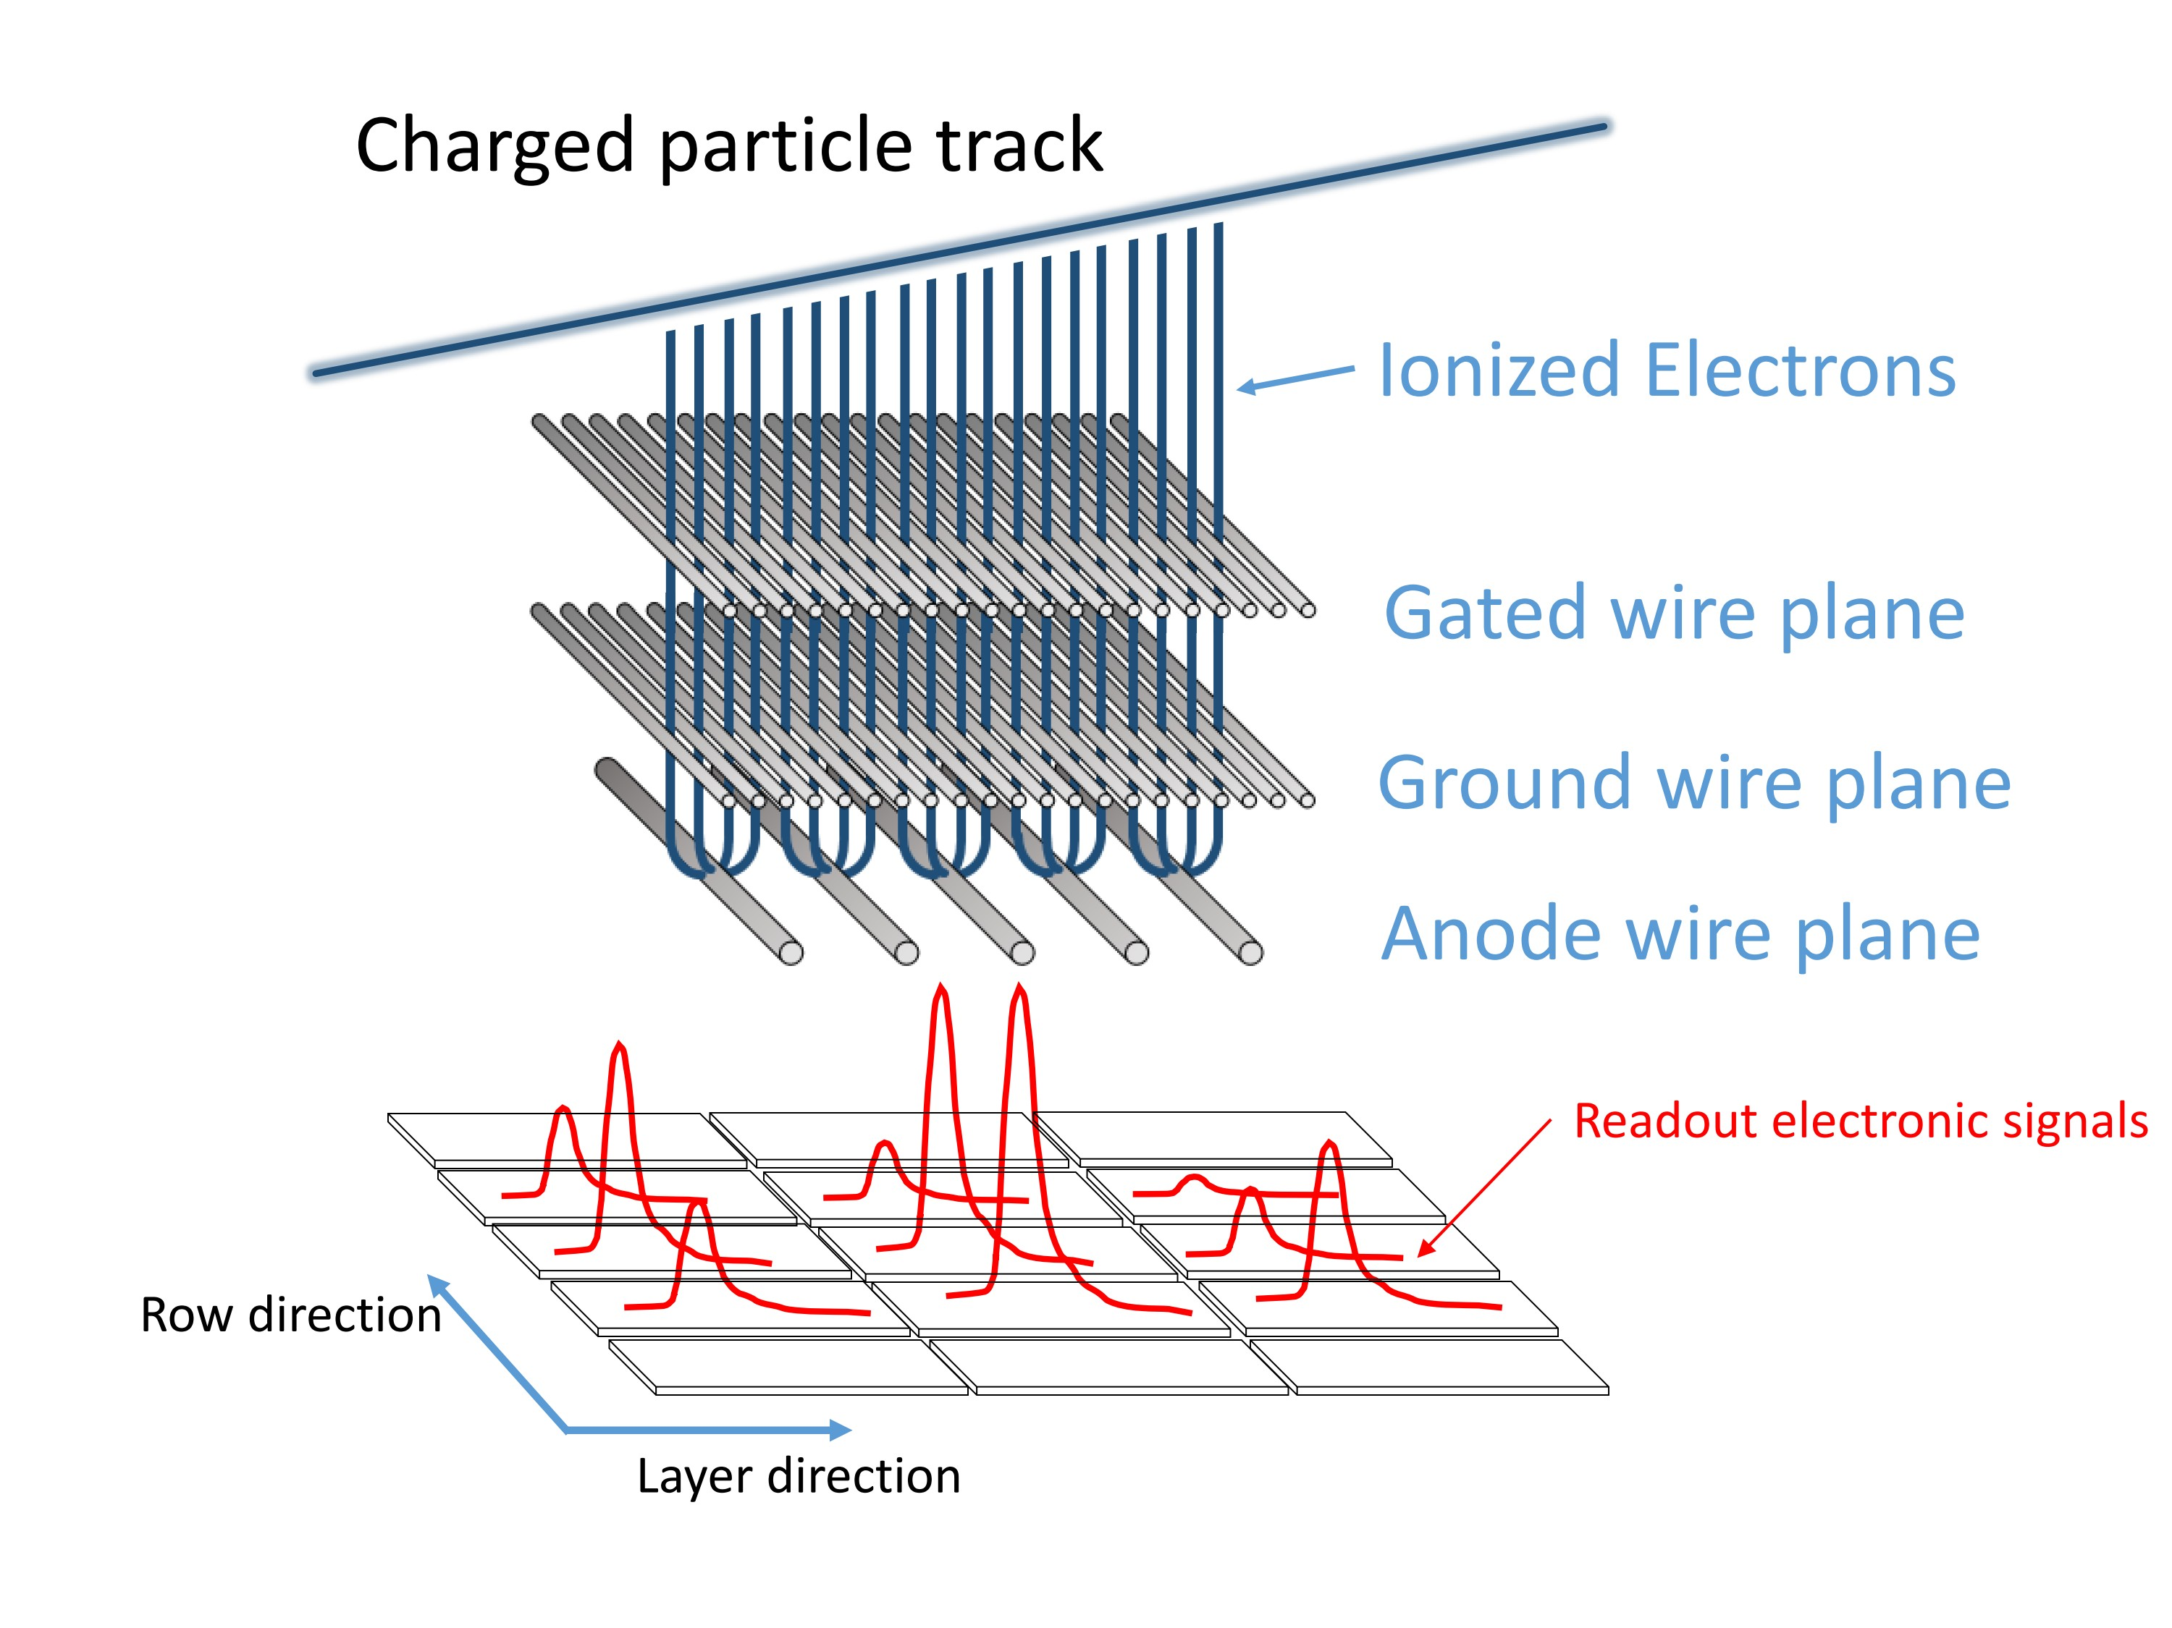

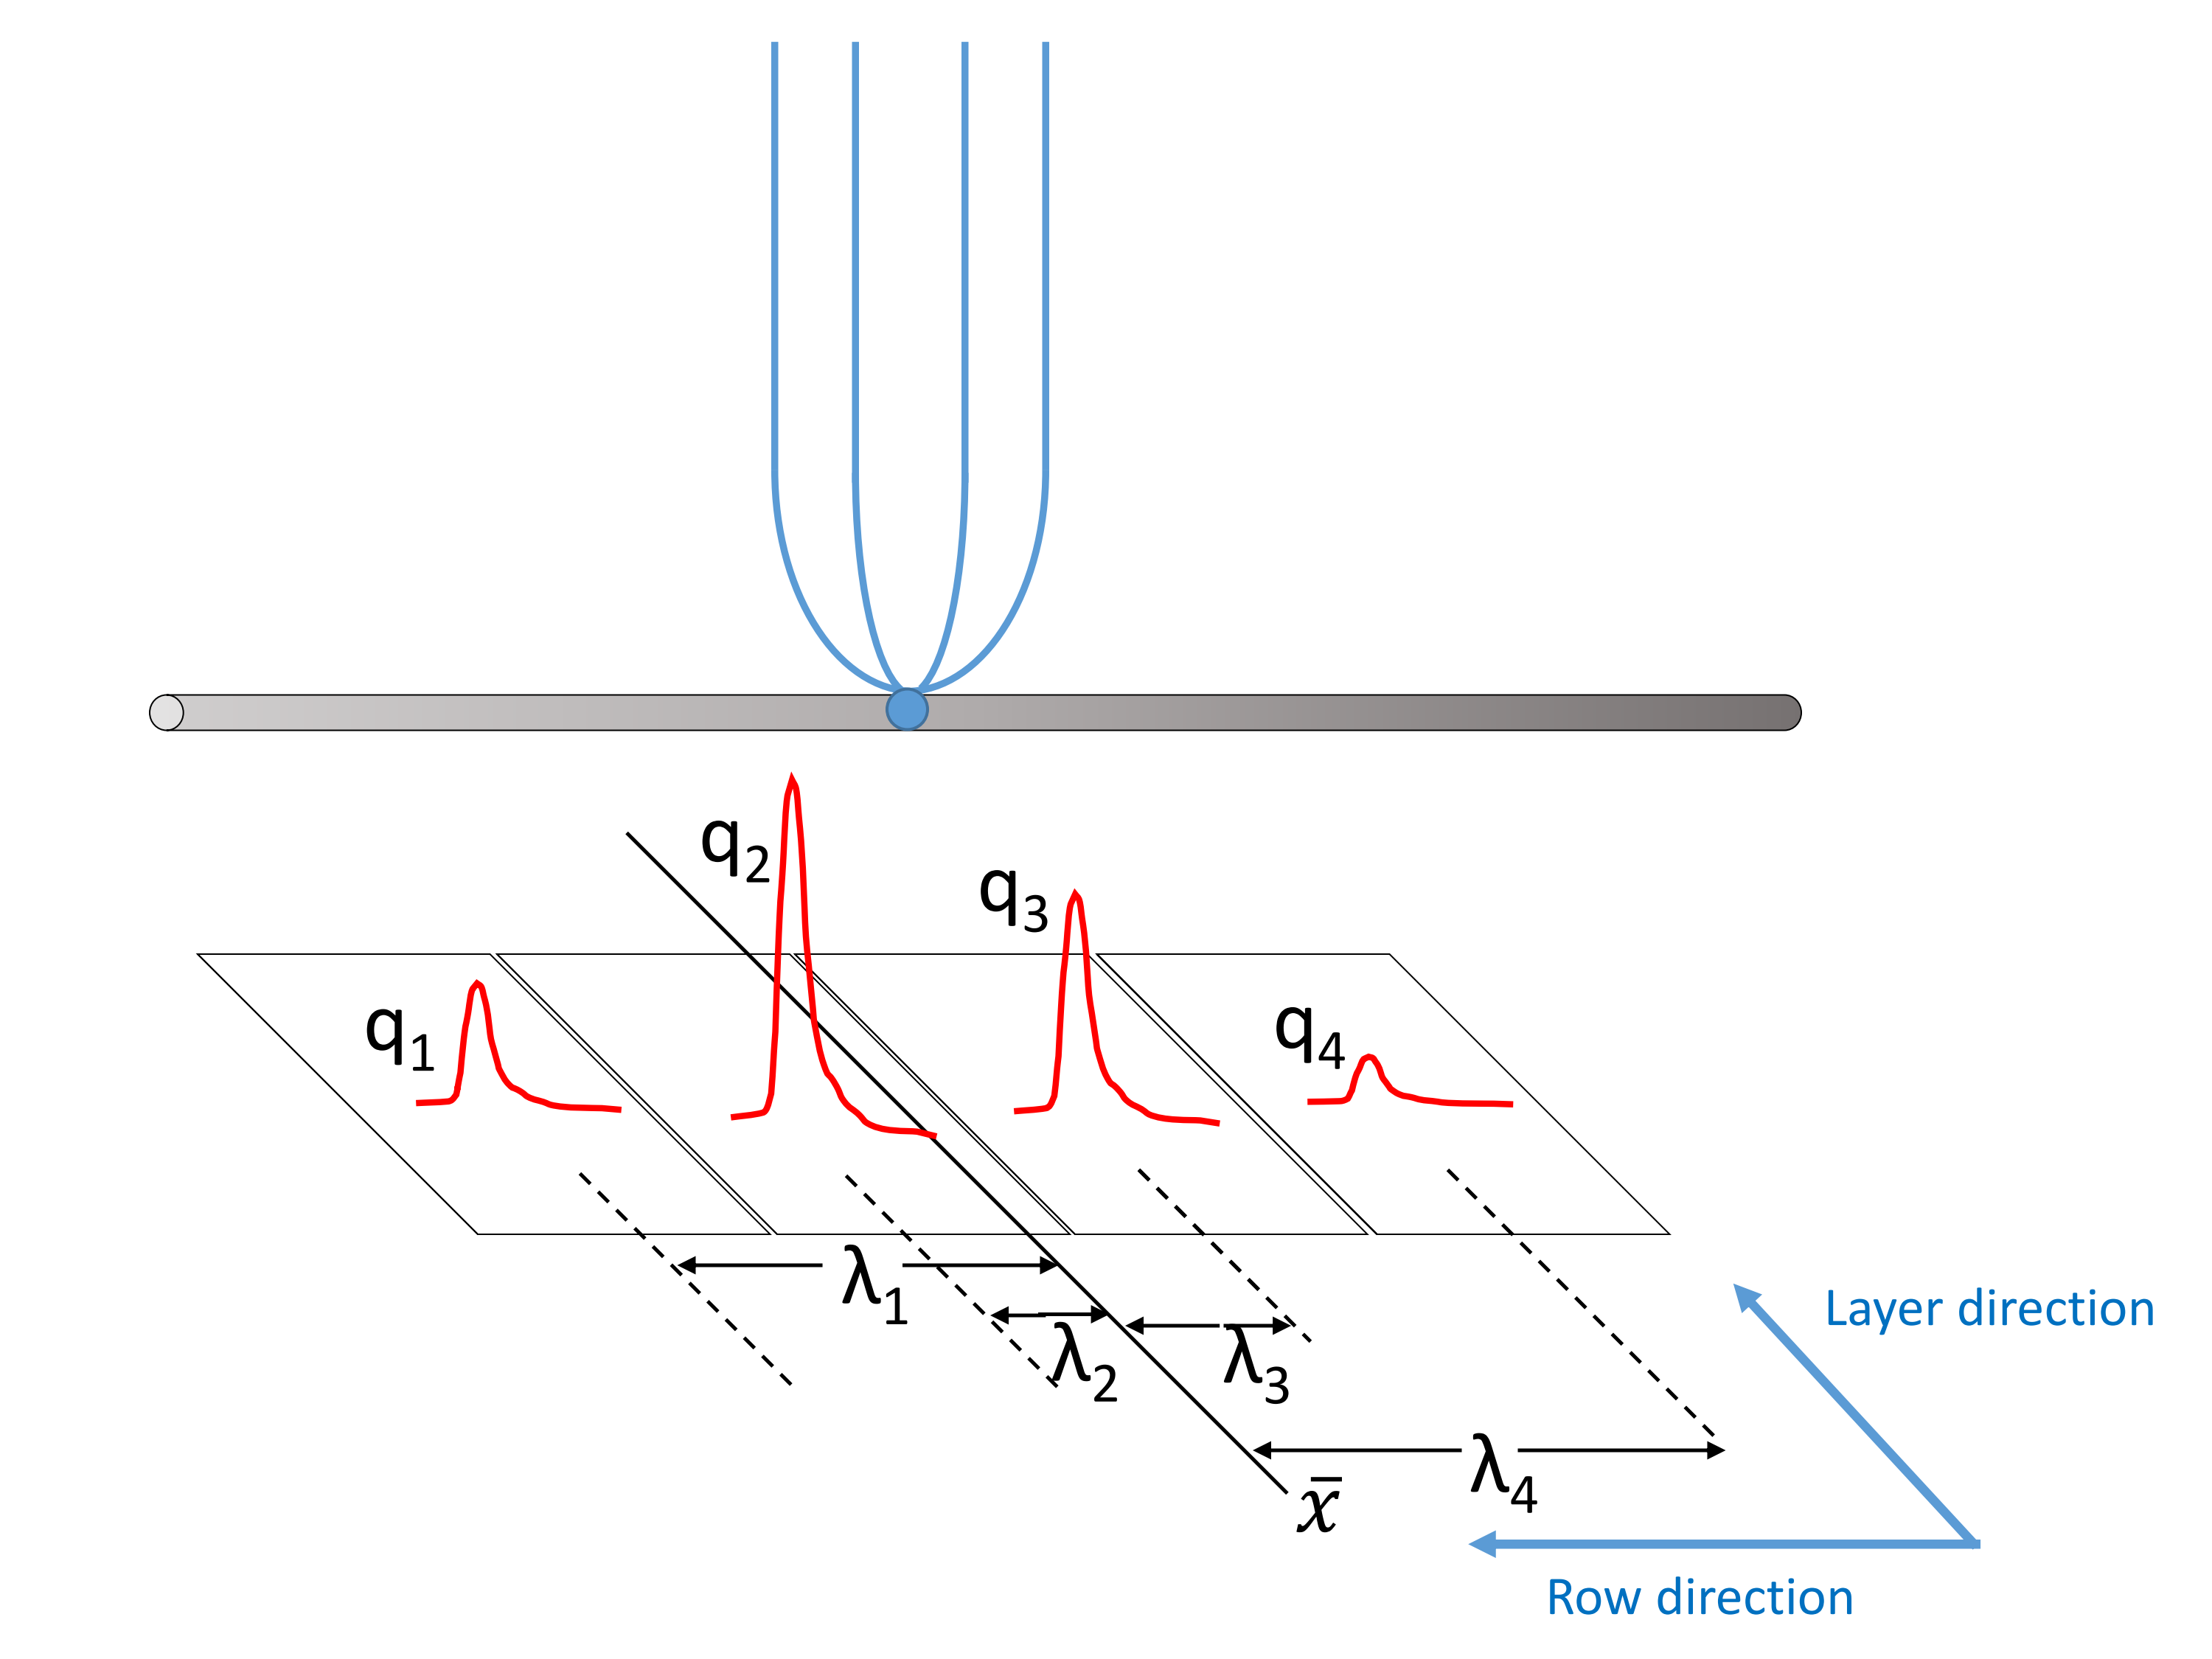Figure 1: Cartoon graphic showing the 3 wire planes and a section of the pad plane. The actual orientation is inverted from this picture but for ease of displaying this orientation fits best.

pendicular is the layer direction for the remainder of this paper.

Figure 2: Cartoon graphic of avalanche event on an anode wire over one layer of pads. The estimate of the position of the avalanche is given by *x*¯ the weighted mean. The position from the center to each pad to the *x*¯ position is given as *λi* .

*q* (*λ* )

*P RF* (*λi* ) = *i i*

*Q*

*General Electronics for TPCs.* The S*π*RIT TPC

50 utilizes the General Electronics for TPCs (GET) to measure and shape the signals from the pad plane [2]. For the first series of experiments, the gain was

*where Q* = ) *qi*

*i*

*and λi* = *xi − x*¯

(1)

set to the highest setting i.e. the dynamic range set was 120 fC over the full 12 bit range ADCs. The

55 shaping time constant was set to 117ns. At such a 75 high gain, the pion signal was able to fully be mea- sured. Though the energy losses of other massive particles measured, (p,d,t,He,Li,..), tend to satu- rate the electronics, especially at lower momenta

60 and higher atomic number z.

80

**2. Pad Response Function**

85

*Experimental PRF.* The fractional charge seen by each pad is referred to as the Pad Response Func- tion (PRF). Some simple wire plane geometries

65 have analytical expressions for the PRF which are well studied and may be looked up using a Gatti 90 distribution [3]. Though theoretical PRFs may be available, Blum and Rolandi still suggest an effec- tive PRF may be required [3]. When analytical

70 PRFs do not exist, an effective PRF may be calcu- lated from experimental data. This is the method 95 used in this paper.

When calculating the effective PRF from exper- iment, it is important to select data that is not saturated, as this will only distort the shape of the PRF. Since the beam comes in along the layer di- rection, the row direction gives the best momentum resolution and was the natural choice for clustering and calculating the PRF.

The PRF is given in equation 1 where i is the in- dex over the pads and Q is the total charge within the layer. In figure 2, the estimate for the avalanche position along the wire is given by the weighted mean position *x*¯. Also seen is *λi* , defined as the dif- ference, in position, of the center of the *ith* pad, *xi* , to the mean position *x*¯. The estimator, *x*¯, can be be obtained from a fitting the full pad distribution or through the weighted mean value. For the SpiRIT TPC the weighted mean value is used.

Calculating the PRF in the way described above, the resulting experimental PRF for the S*π*RIT TPC is seen in figure 2. The PRF obtained from a of the experimental data seems to be well behaved. There are three main areas around -8,0, and 8mm which contain most of the data. These values cor- respond to 3 pads, where each neighboring pad is

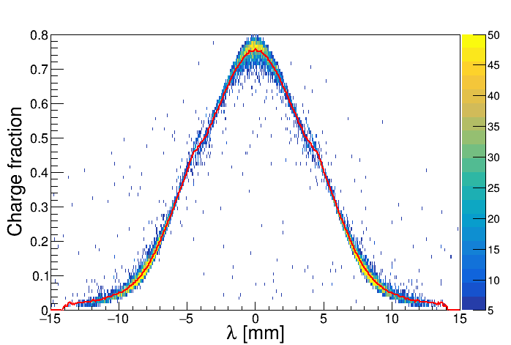

100

8mm apart on center. The values around *±*4mm show a strange behavior where the value splits into two forks. There are actually small non-conducting gaps between adjacent pads that cause this behav- ior. The functional form could not be well described by any reasonable function. Instead the mean val- ues of this distribution were taken as estimates for the PRF. The values in-between were calculated by

135

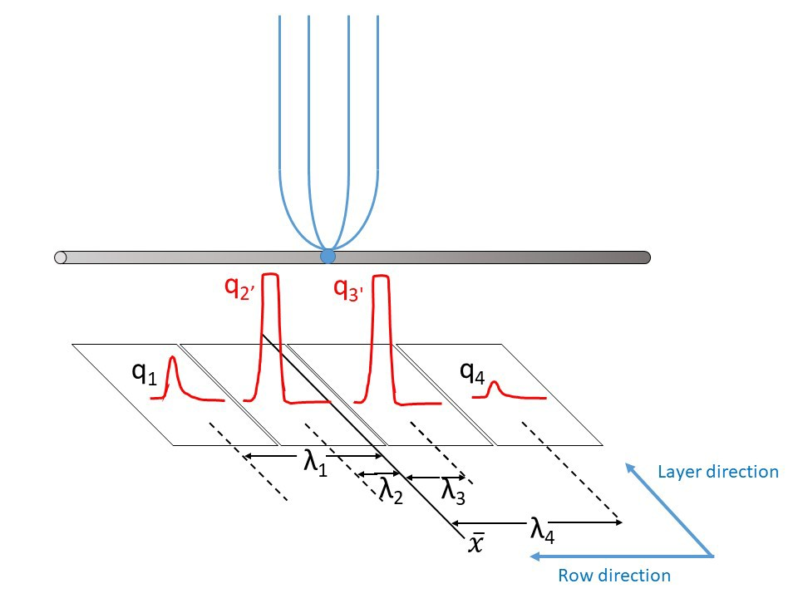(6) Construct the *χ*2 value as described in Equation

2

(7) Repeat steps until the *χ*2 minimum is found.

Returning unknown charges and *x*¯.

2

105

a cubic spline interpolation

*χ*2 = ) *v*((*λi* ) *− n*(*λi* ))

*v*(*λi* )

(2)

110

115

120

125

*Method of Desaturaiton.* Figure 2 shows a typical

situation of saturated signals. This will be used as an example to explain the method of extrapolating the saturated pads, which I refer to in this paper as desaturation. When an avalanche causes an in- duced signal so large, the pads directly underneath collect the largest charge and typically would be saturated. These are represented as *q*1*!* and *q*2*!* in the figure 2. The pads further away would experi- ence smaller, non-saturated signals.

Though we don’t know the charge of the satu- rated pads, we know that all the pads charges must satisfy the PRF shape. Thus, using these small non-saturated tails of the distribution we extrap- olate using the known PRF to get the unknown, saturated, charges.

The method is summarized as such:

(1) Get unknown, saturated, charge values from numerical minimizer

(2) Calculate total charge, Q, within layer. Also calculate weighted mean *x*¯

(3) Using the mean value *x*¯. Calculate *λi* for each pad

140

145

150

155

*i*

**3. Experimental data**

A tuned cocktail beam consisting of (p,d,t,3 *H e*,4 *H e*,6 *Li*,7 *Li*) light charged parti- cles was injected into the TPC for calibration purposes. The cocktail beam was tuned to two different *βρ* settings and the momentum resolution was approximately 1% as determined by the slits of the BigRIPS separator. A thick 21mm thick aluminum target was inserted for part of the lower

*βρ* setting, further reducing the energy of the beam for a third calibration point.

**4. Results**

It is expected that all the PID lines should share a common energy loss curve differing only by their mass and atomic number. The data was corrected for mass by calculating the *βγ* and the *dE* was cor- rected for *z*2 , the atomic number, and a gain cali- bration was applied. It is seen that the p,d,t which

*dx*

130

(4) Calculate *n*(*λi* ) = *qi*

for each pad.

*Q*

the measured PRF value

do not suffer from saturation in this range all share a common PID line as expected. The higher mo-

(5) Get the expected PRF value, *v*(*λi* ) = *P RF* (*λi* ), using the *λi* calculated in (3), and the PRF calculated from experimental data.

160

mentum of 3 *H e* and 4 *H e* also share the common

line. The lower end of the He and also the Li species suffer from saturation effects as see

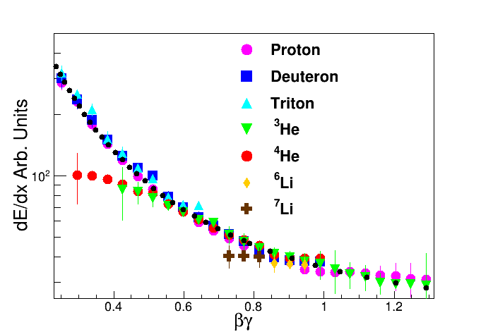

Figure 3: Raw data for the various light particle species.  *dE* values scaled by atomic number *z*2 . Black curve represented the expected values given by Bichsel curves, after gain cali- bration.

*dx*

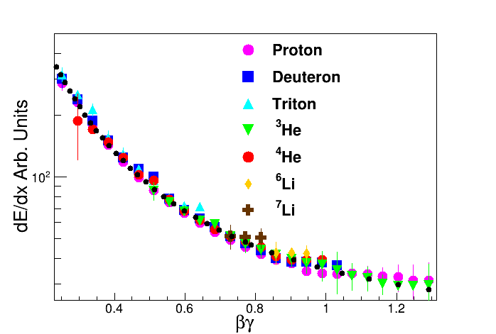

Figure 4: Desaturation applied. You can see the data now is corrected by the desaturation routine. Especially for He particles. Also notice the Li species now have a clear sep- aration where as before they were compressed together due to saturation.

n by their PID lines diverging from the common

PID lines. It is especially noticeable for the He

175

180

[doi:10.1016/j.nima.2015.01.026](http://dx.doi.org/10.1016/j.nima.2015.01.026).

[2] E. P. et. al., Get: A generic and comprehensive elec- tronics system for nuclear physics experiments, Physics Procedia 37 (2012) 1799–1804. [doi:10.1016/j.phpro.](http://dx.doi.org/10.1016/j.phpro.2012.02.506)

[2012.02.506](http://dx.doi.org/10.1016/j.phpro.2012.02.506).

[3] W. Blum, W. Riegler, L. Rolandi, Particle Detection with Drift Chambers, Springer, Berlin, Heidelberg, 2008.

species at low *βγ* where the  *dE*

*dx*

value diverges by

165

about a factor of 2.5. Applying the method de- scribed to the same set of data, we can see signif-

icant improvement in the  *dE*

*dx*

values as shown in

figure 3. It is impressive that not only the shape of the He species is returned but also the separation of the Li species is restored as well.

170

**5. Conclusion**

**References**

[1] R. S. et. al., S*π*rit: A time-projection chamber for symmetry-energy studies, NIM A 784 (2015) 513–517.